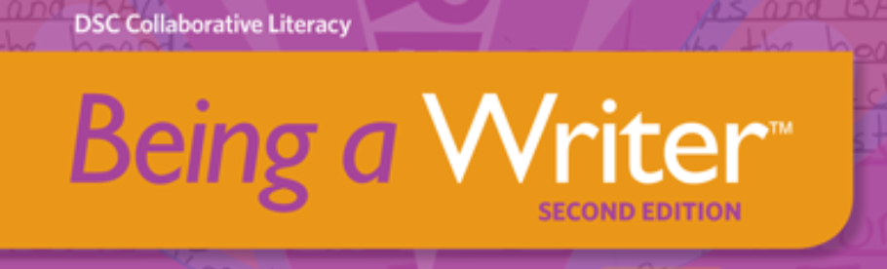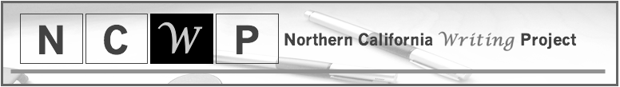

Click Here to Apply

for the

C3WP

Introduction/Refresher

Advanced Institute

**NCWP 2019 C3WP Introduction/Refresher**

**Advanced Institute – Invitation Only**

The Northern California Writing Project has been sharing the nationally recognized College, Career and Community Writers’ Program (C3WP) with schools throughout our region for the past several years. C3WP focuses on argument writing, specifically, but also provides wonderful instructional resources and strategies for teaching literacy across grade levels and disciplines. Teachers receiving this invitation may have demonstrated exceptional teaching practice and knowledge in another NCWP program or have been through the C3WP Advanced Institute before. This advanced institute will provide an opportunity for NCWP teacher-consultants to experience and implement instructional resources that help teacher and students these instructional resources read critically, explore multiple points of view, and take a stand on important issues. This program initially developed instructional resources for middle and high school age students, but recently has expanded the program to include 4th – 6th grade teachers and students. The NCWP C3WP Introduction/Refresher Advanced Institute offers NCWP teacher-consultants the opportunity to receive over 45 hours of professional development designed to assist with the integration of these proven resources within existing curriculum. Teacher-consultants from the Northern California Writing Project will share reading and writing instructional strategies through a combination of direct instruction, classroom modeling and mentoring to help your students become better readers and writers. Current literacy practices and research will provide the foundation for elementary school teachers. Special attention will be given to ensure instructional practices align with content-area demands, textbook adoptions and state mandates. Sessions will focus on engaging students with interesting and relevant readings, analyzing and using mentor texts to support student writers.

**Details:**

* ***Date: July 29 – August 1, 2019***
* ***Time:* 9:00 am – 3:00 pm**
* ***Where: CSU Chico***
* ***Cost: Costs associated with travel, including mileage, lodging and per diem***
* ***Stipend to be paid in 3 increments:***
* ***$500.00 after summer boot camp (20 hour)***
* ***$500.00 in December upon completion of 2 cycles of instruction. (15 hours)***
* ***$500.00 in May upon completion of 2 cycles of instruction (15 hours)***
* ***Pre-registration required***
* ***3 units of Professional Learning Units available at extra cost.***

The NCWP 2019 C3WP Introduction/Refresher Advanced Institute is very limited. If you have questions or would like additional information please contact Carla Truttman, Inservice Co-Director at [ctruttman@yuhsd.net](mailto:ctruttman@yuhsd.net) or (530) 340-1087.

About the NCWP:

* Approved provider of professional development under Elementary and Secondary Education Act
* Research-proven results: student writing improves in content, structure, conventions, and stance
* Workshops, seminars, and model lessons led by expert classroom teachers
* Effective, classroom-proven reading and writing strategies
* Inquiry- and Project-Based Learning
* Engaging, experienced staff development team

Phone: 530-898-5322

**Website:** norcalwp.org

**Email**: [ncwp-admin@csuchico.edu](mailto:ncwp-admin@csuchico.edu)